Online New Student Admissions
Gadsden State Community College

Gadsden Campus Ayers Campus McClellan Center Cherokee Center
Phone: (256) 549.8200 Phone: (256) 835.5400 Phone: (256) 238.8342 Phone: (256) 927-1809
Fax: (256) 549.8205 Fax: (256) 835.5479 Fax: (256) 238.9360 Fax: (256) 927-1810

Go to the Gadsden State Website. www.gadsdenstate.edu

Click on Apply Now!

Complete the application by entering your information.

Click Submit.

Print & complete a State Residency Form, and mail or fax to Gadsden State.

Bring a copy of your Driver’s License or State Photo ID to the Admissions office. If you cannot make it to the Admissions office you will have to make a copy of your ID, have the copy notarized and mail it to the Admissions office (faxed copies are not accepted).

Have an official copy of your high school transcript or GED scores sent to the Admissions office. If you are a transfer student, have official transcripts sent from all colleges you previously attended.

- At any time you may check your Admission status by logging in to the Self Service Banner

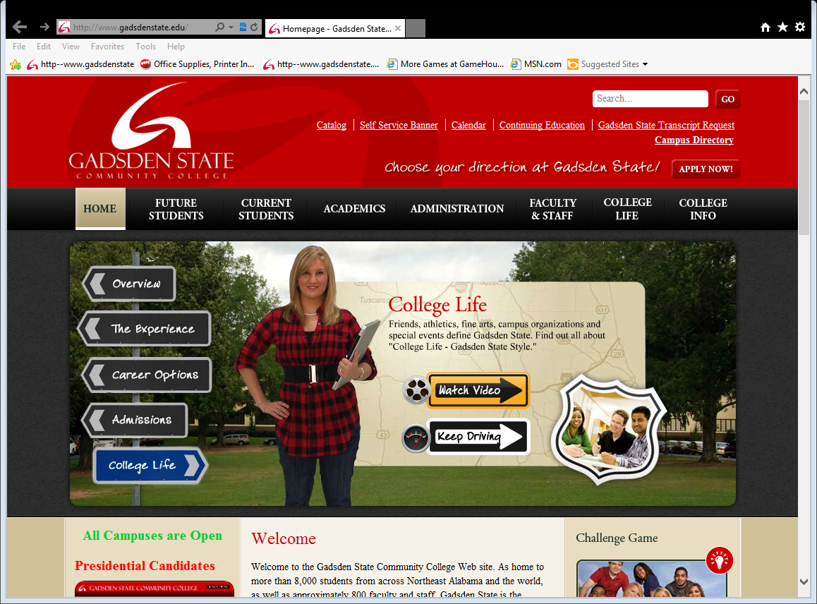

Gadsden State Admissions & Enrollment Checklist
⁭ Apply for Admission.
Complete the process on the reverse page

⁭ Apply for Financial Aid.
Complete the Free Application for Federal Student Aid (FAFSA) to determine your eligibility for financial aid. The FAFSA becomes available January 1 of each year. Apply for aid as soon as possible after January 1. Apply online at www.fafsa.gov or call 1-800-433-3243 for a paper application. Typically, you will be able to access your SAR (Student Aid Report) within 2 weeks of filing your FAFSA. If you do not receive your SAR electronically or by mail, please call the Federal Processing Center at 1-800-433-3243. After filing your FAFSA wait 3-5 business days and begin checking your SSB (Self Service Banner). Select the Financial Aid Tab, then click Student Requirements. Submit the documents requested as soon as possible.

Gadsden Campus: (256) 549.8267 Ayers Campus: (256) 835.5420 McClellan Center: (256) 238.9341
Cherokee Campus: 256-927-1801

⁭ COMPASS Placement Test
Placement testing is required for some students prior to registration. The test takes approximately two hours to complete and will determine your placement in math, English, and reading courses. Once testing is completed, please notify the Admissions office, to determine if you are clear for registration.
Summer 2014-COMPASS Placement Testing:
Wallace Drive Campus: (256) 549.8497. Monday –Thursday, 8:00 a.m.-12:00 noon

Ayers Campus: (256) 835.5411. Monday & Tuesday, 8:00 a.m.–2:00 p.m.; Wednesday-4pm

McClellan Center: (256) 238.9348. Monday –Thursday, 8:00 a.m.-2:00 p.m.

Cherokee Center: (256) 927.1800. Wednesday &Thursday, 8:00 a.m. & 1:00 p.m. (call for appointment)

⁭ Academic Advisement
Students should meet with Gadsden State counselors and/or advisors to develop their schedules for the chosen major.
NOTE: Ask a counselor or your advisor about STARS (Statewide Articulation & Reporting System) if you plan to transfer to a four-year college. You can download a list of the courses to complete at Gadsden State that will transfer to your chosen university. http://stars.troy.edu.

⁭ Register for classes
Registration and tuition payment can be completed by logging into the Self Service Banner at www.gadsdenstate.edu.
Payment is due at the time of registration. Payment can be made by check, cash, money order, travelers checks and credit cards (Visa / MasterCard / American Express) at the Business Office (Wallace Drive, East Broad, Ayers, Cherokee or McClellan). The Cherokee and McClellan Centers do not accept cash or credit card payments. If your financial aid process is complete, you can apply your financial aid online.
⁭
Verify your class schedule
Check your schedule one week after you register by using the Self Service Banner at www.gadsdenstate.edu.
Click on the Self Service Banner link on the home page (see homepage on reverse side). Print your schedule from the “View your Schedule” option to verify if it is correct.

⁭ Student ID
Students are required to obtain a student identification card once registered for classes. Student must carry Student ID’s at all times while on campus or when participating in student activities.
⁭ Parking Hang Tag
All students are required to register their vehicles on any Gadsden State campus.

⁭ Student E-Mail System
Check your student e-mail on the Gadsden State webpage, www.gadsdenstate.edu. Click on Student Email and then
enter your Blackboard or first part of Student Email

It is the policy of the Alabama State Board of Education and Gadsden State Community College, a postsecondary institution under its control, that no person in Alabama shall on the grounds of race, color, disability, sex, religion, creed, national origin, or age be excluded from participation in, be denied the benefits of, or be subjected to discrimination under any program, activity, or employment
. 05/07/2014

